PIZZA SALES SQL QUERIES
A. KPI’s
1. Total Revenue
select sum(total_price) as Total_Revenue from pizza_sales1;
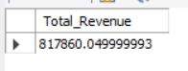
2. Average Order Value
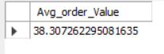
select sum(total_price) / count(distinct order_id) as Avg_order_Value from pizza_sales1;
3. Total Pizza Sold
select sum(quantity) as Total_pizza_sold from pizza_sales1;
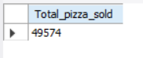

4. Total Orders
select count(distinct order_id) as Total_orders from pizza_sales1;
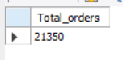

5. Average Pizzas Per Order
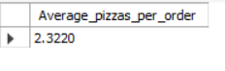
select sum(quantity) / count(distinct order_id) as Average_pizzas_per_order from pizza_sales1;

B. Daily Trend for Total Order
select dayname(order_date) as order_day, count(distinct order_id)as total_orders from pizza_sales1
GROUP BY DAYOFWEEK(order_date), DAYNAME(order_date)
ORDER BY DAYOFWEEK(order_date);
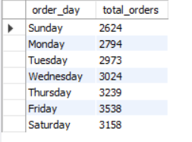

C. Monthly Trend for Total Orders
SELECT
MONTHNAME(order_date) AS month_name,
COUNT(DISTINCT order_id) AS total_orders
FROM pizza_sales1
GROUP BY MONTH(order_date), MONTHNAME(order_date)
ORDER BY total_orders DESC;
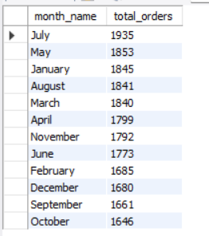

D. Sales Percentage by pizza Category
select pizza_category, sum(total_price) as Total_price,round( sum(total_price) * 100.0 / (select sum(total_price) from pizza_sales1), 2) as PCT
from pizza_sales1
group by pizza_category;
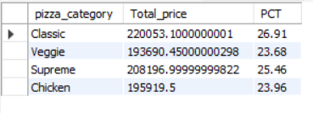
E. Sales Percentage by pizza Size
select pizza_size, round(sum(total_price), 2) as Total_price,round( sum(total_price) * 100.0 / (select sum(total_price) from pizza_sales1),2 )as PCT
from pizza_sales1
group by pizza_size
order by PCT desc;
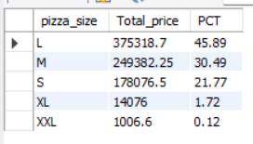

F. Top 5 Best Seller Pizzas
select pizza_name, sum(total_price) as Total_revenue from pizza_sales1
group by pizza_name
order by total_revenue desc
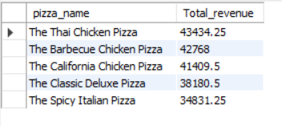
limit 5;

G. Bottom 5 Seller Pizzas
select pizza_name, sum(total_price) as Total_revenue from pizza_sales1
group by pizza_name
order by total_revenue asc
limit 5;
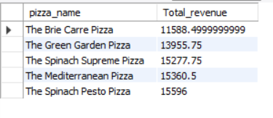
H. Top 5 Best Seller Pizza by Quantity
select pizza_name, sum(quantity) as Total_quantity from pizza_sales1
group by pizza_name
order by Total_quantity desc
limit 5;
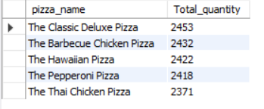

I. Bottom 5 Best Seller Pizza by Quantity
select pizza_name, sum(total_price) as Total_revenue from pizza_sales1
group by pizza_name
order by total_revenue asc
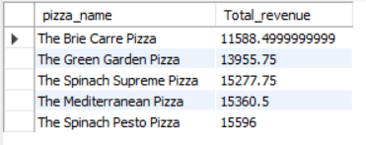
limit 5;

